##### " Cola Fun Notebook"

##### 

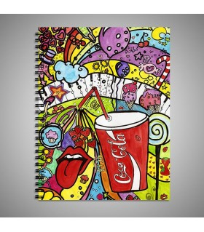

**Price: Rs.700/-**

Cool Cola fun art printed for kids available in different sizes and colors.

Some of our loveliest relationships are with our Notebooks. Those trusty places to scribble big ideas, little reminders and anything that inspires you throughout the day. Once you’ve chosen whether you want lined, dotted or plain paper inside, personalize your Notebook with a name, a fun title– anything you like!

* Model Number: 20785856119
* Type: Notebook
* Promotional: No
* Style: Line
* Display Screen: show as the picture
* Use: Paper
* Origin: Japan
* Color: white, blue, black.
* Size: 6.5cm x 12cm x1cm
* Type 1: Casual Notebook